Trailer Lighting Status – CGEA1.3

Functional Description

The Trailer Lighting Status on-demand screen provides an indication to the driver through the message center the condition of the trailer lights if a trailer is connected.

The Trailer Lighting Status correlate the Parklamp_Status signal from the BCM module, the Trailer_Connected_MC_Status_Flag, Trailer_Stop_Lamps_Fault_MC_Status_Flag, Trailer_Left_Turn_Lamps_Fault_MC_Status_Flag, Trailer_Right_Turn_Lamps_Fault_MC_Status_Flag, and Trailer_Stop_Lamps_Fault_MC_Status_Flag from the Warning – Trailer STSS, the Operational_Mode, and the Trailer_Lighting_Status_Cfg bits to display the appropriate Trailer Lighting Status in the message center. The logic in the specification supports trailers with a combined Stop/Turn Lamp. European regulations require separate Stop and Turn lamps. For this reason, this specification does not support the TTLM used in Europe.

This specification is to be used in conjunction with "Warning – Trailer" STSS.

Interfaces

Interface Context Diagram (I/O Block Diagram)

Figure 1 Trailer Lighting Status Context Diagram

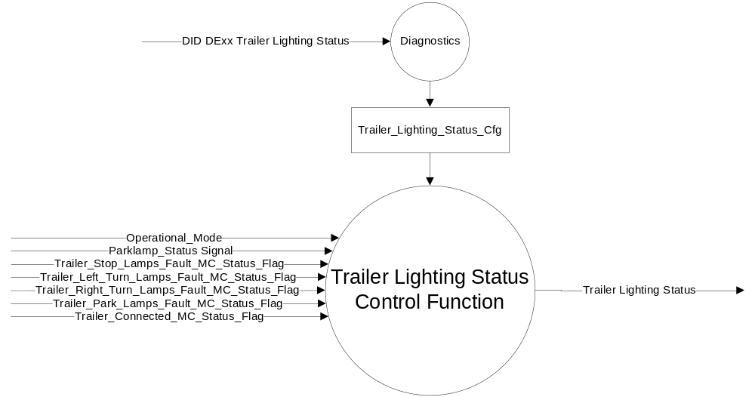

Inputs
      - INTERNAL:
    - Operational_Mode
    - Trailer_Lighting_Status_Cfg
    - Trailer_Connected_MC_Status_Flag (from the Warning – Trailer STSS)
    - Trailer_Stop_Lamps_Fault_MC_Status_Flag (from the Warning – Trailer STSS)
    - Trailer_Left_Turn_Lamps_Fault_MC_Status_Flag (from the Warning – Trailer STSS)
    - Trailer_Right_Turn_Lamps_Fault_MC_Status_Flag (from the Warning – Trailer STSS)
    - Trailer_Park_Lamps_Fault_MC_Status_Flag (from the Warning – Trailer STSS)

- MUX message from the CAN bus

- Parklamp_Status Signal
Signal Name | Size (bits) | Detail | Units | Res. | Offset | State  Encoded | Min | Max
Parklamp_Status | 2 |  | SED | 1 | 0 |  | 0 (0x0) | 3 (0x3)
 |  | Off |  |  |  | 0x0
 |  | On |  |  |  | 0x1
 |  | Unknown |  |  |  | 0x2
 |  | Invalid |  |  |  | 0x3

Output

- Trailer Lighting Status

Function/Performance

Operational Modes

Mode | Differentiating Vehicle Conditions
Sleep Mode | Inactive
Limited Mode | Inactive
Normal Mode | Inactive/Active
Crank Mode | Inactive/Active

The above table references the setting of the flags as per this section. However, the actual display operational modes are defined in the Message Center section of this SPSS.

Voltage Levels

Refer to the Cluster Features Table located in the Operational Modes and Voltage Range Strategies Section of this SPSS

Human-Machine Interface

Visual

1.3.3.1.1 Indicator Graphics / Display Format
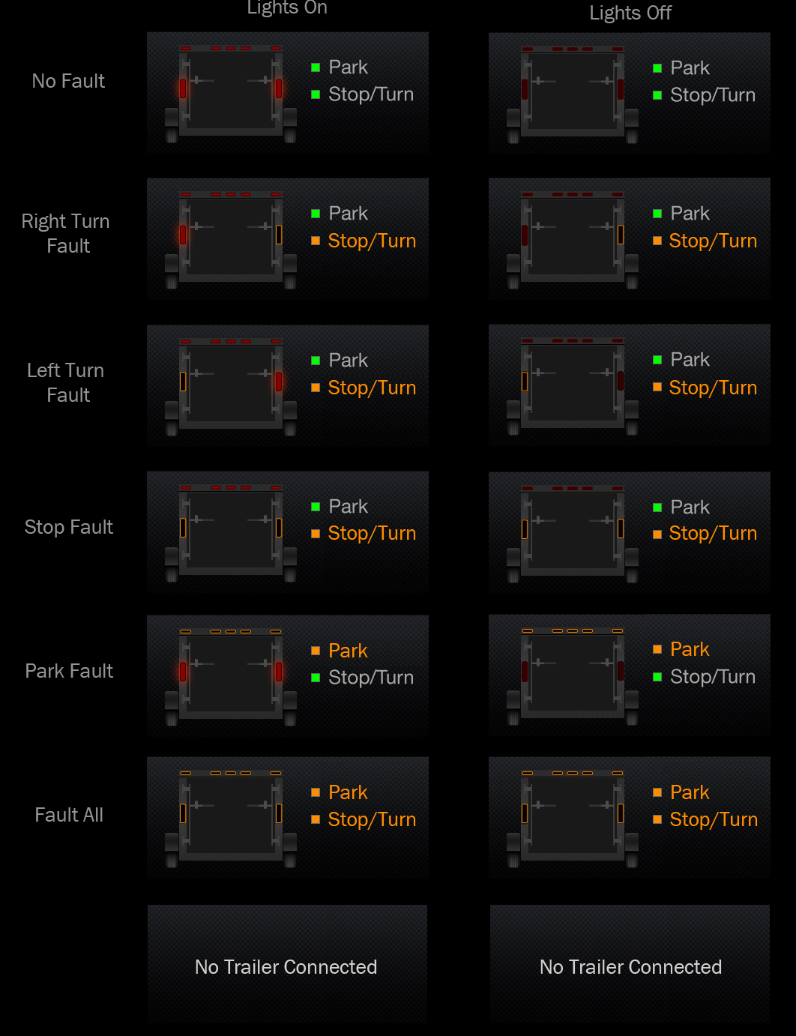

1.3.3.1.2 Indicator Color Coordinates

Reference section COLOR & ILLUMINATION REQUIREMENTS (GRAPHICS).

Audio

None.

Switch Control Logic

None.

System Accuracy

Within 100 msec of receiving a message that results in a change of state the cluster will update the output flag to the proper state.

Operation: Performance and Functional

Subsystem Algorithm Flowchart / State Diagram

Figure 2 DID DExx Flow Chart

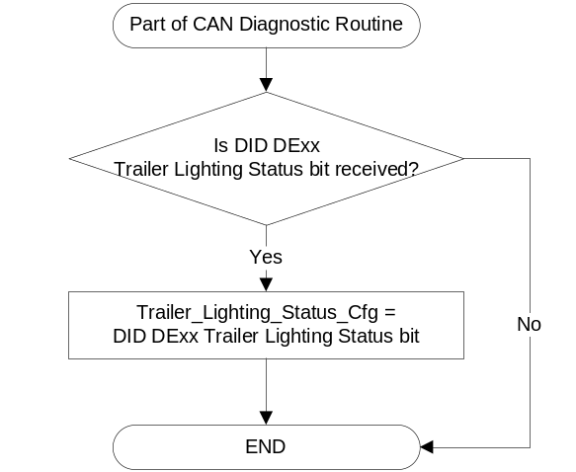

- “Stop/Turn” Text Color
Operational_  Mode | Trailer_Connected_  MC_Status_Flag | Trailer_Stop_  Lamps_Fault_  MC_Status_Flag | Trailer_Left_Turn_  Lamps_Fault_  MC_Status_Flag | Trailer_Right_Turn_  Lamps_Fault_  MC_Status_Flag | “Stop/Turn”  Text Color
Normal or Crank | ACTIVE | ACTIVE | X | X | Amber
Normal or Crank | ACTIVE | X | ACTIVE | X | Amber
Normal or Crank | ACTIVE | X | X | ACTIVE | Amber
Normal or Crank | ACTIVE | INACTIVE | INACTIVE | INACTIVE | Neutral/Green
Normal or Crank | INACTIVE | X | X | X | Text not displayed
All Other Cases |  |  |  |  | Text not displayed

Note: Actual Text and Color is determined by the HMI group.

- “Park” Text Color
Operational_  Mode | Trailer_Connected_  MC_Status_Flag | Trailer_Park_  Lamps_Fault_  MC_Status_Flag | “Park”  Text Color
Normal or Crank | ACTIVE | ACTIVE | Amber
Normal or Crank | ACTIVE | INACTIVE | Neutral/Green
Normal or Crank | INACTIVE | X | Text not displayed
All Other Cases |  |  | Text not displayed

Note: Actual Text and Color is determined by the HMI group.

Figure 3 Left/Stop Lamp Graphic Flow Chart

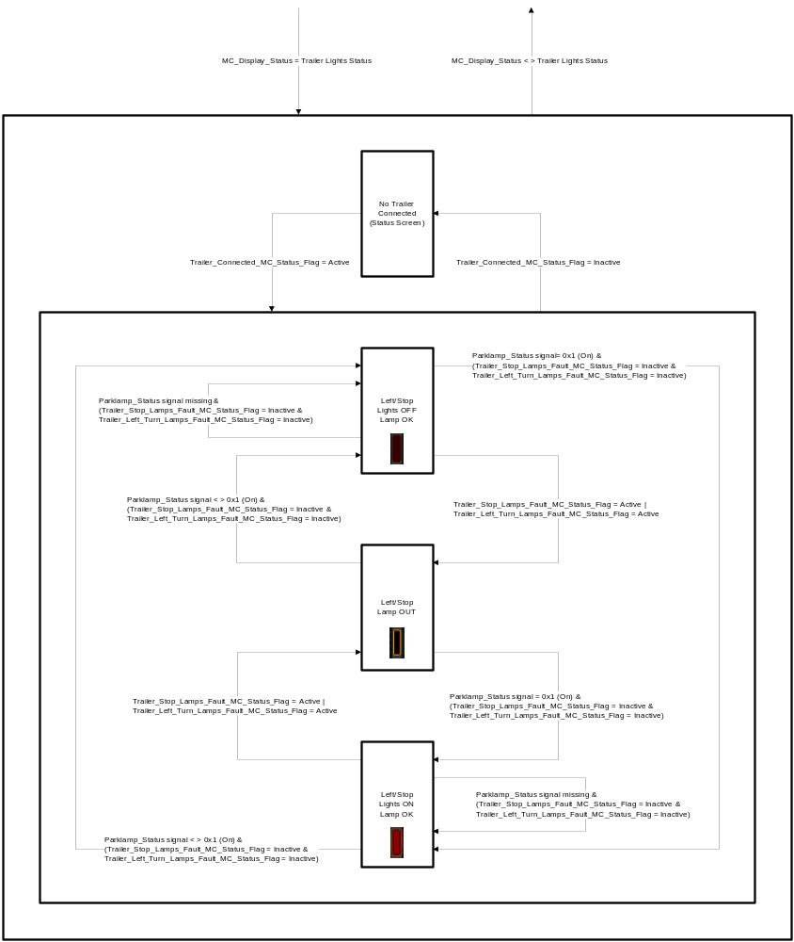

Note: Actual Graphic and Color is determined by the HMI group.
Figure 4 Right/Stop Lamp Graphic Flow Chart

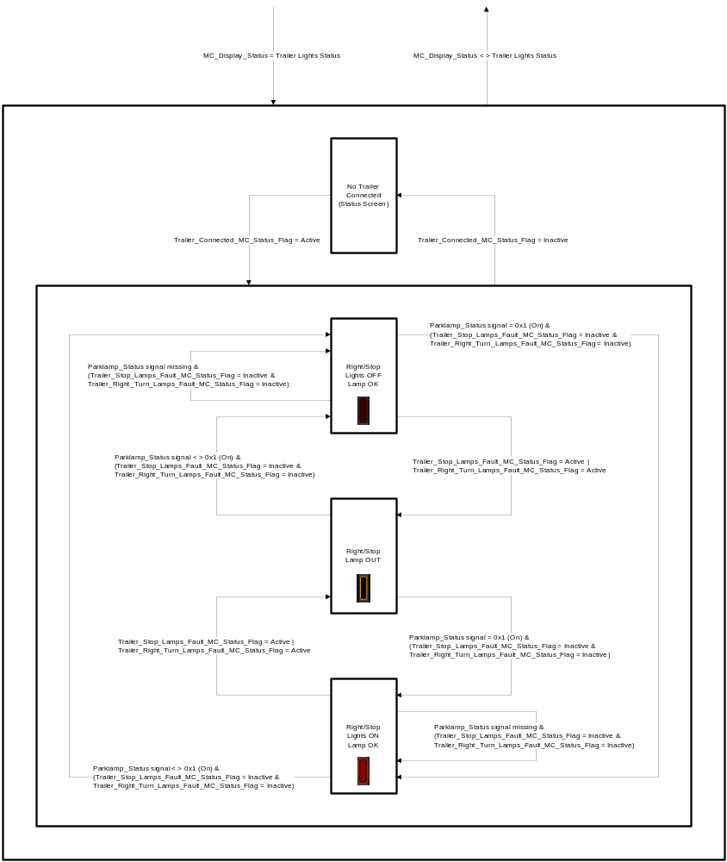

Note: Actual Graphic and Color is determined by the HMI group.
Figure 5 Park Lamp Graphic Flow Chart

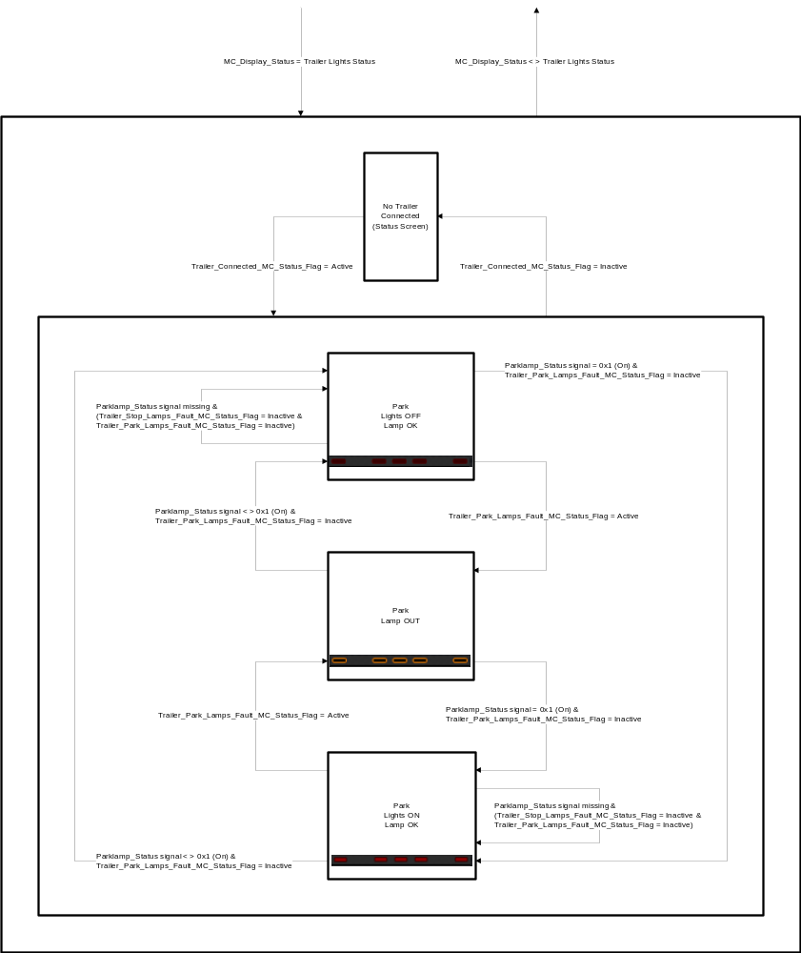

Note: Actual Graphic and Color is determined by the HMI group.

Operation Description (supports algorithm flowchart /state diagram)

- The Trailer Lighting Status screen is only available if Trailer_Lighting_Status_Cfg is Enabled.
- The Left/Stop lamp, Right/Stop lamp, and Park lamps will behave independently in the graphics as per the flowcharts. Each lamp can have three different indicated statuses if a trailer is connected: Light Off and Lamp OK, Lights On and Lamp OK, or Lamp Out.
- If there is no trailer connected, the Trailer Lighting Status screen will indicate as such.
- The color of the text will be used to indicate an OK or fault condition of the Stop/Turn Lamps and the Park Lamps as per Table 1.1 and Table 1.2, respectively.

Function Safety Classification (EMC)

Class B

Memory Storage

Parameter Name | Description | Value at  Battery Connect | Value at  Module Wake-up
Parklamp_Status Signal | CAN Signal sent from the BCM | Off (0x0) | Off (0x0)
Trailer_Lighting_Status_Cfg | Configures cluster to allow Trailer Lighting Status screen to be displayed. (set to disable at cluster end of line) | Use Stored Value | Use Stored Value
Trailer_Connected_MC_Status_Flag | State variable used by M/C Warning Arbitrator | INACTIVE | INACTIVE
Trailer_Stop_Lamps_Fault_MC_Status_Flag | Used to control the state of the warning to the Message Center arbitrator | INACTIVE | INACTIVE
Trailer_Left_Turn_Lamps_Fault_MC_Status_Flag | Used to control the state of the warning to the Message Center arbitrator | INACTIVE | INACTIVE
Trailer_Right_Turn_Lamps_Fault_MC_Status_Flag | Used to control the state of the warning to the Message Center arbitrator | INACTIVE | INACTIVE
Trailer_Park_Lamps_Fault_MC_Status_Flag | Used to control the state of the warning to the Message Center arbitrator | INACTIVE | INACTIVE
Operational_Mode | 4 state indicator for cluster operational mode | Limited | Limited or Normal or Crank

Prove Out

No.

Reconfigurable Telltale

No.

Message Center Msg

None.

Error Handling

Missing Message Strategy

The signals will be declared missing as per the Diagnostics section of this SPSS.

DTCs states and history will be determined as per the Diagnostics section of this SPSS.

If Trailer_Lighting_Status_Cfg = Disabled, the cluster shall never log a missing message DTC due to this feature

Diagnostics

Self Test

None

Engineering Test Mode

Not Applicable

Part II Performance

Supported Diagnostic Trouble Codes (DTCs)
DTC | Description
C14000 | Lost Communication With Body Control Module Missing Message

DID DExx
Block  Num | Block Description | Byte(s) | Bits | State: Description | "0" | "1" | Default | Comments/Information
PACKETED BLOCKS
$ xx | Option Content (B&A) | * | * | Trailer Lighting Status | Disabled | Enabled | Disabled | Enabled indicates the presence of the Trailer Tow Lighting Module and the Trailer Lighting Status screen.  Note: This cfg bit must be Disabled if the Trailer_Lighting_Cfg bit of the Warning - Trailer Lighting STSS is Disabled. Would expect this cfg bit to be Enabled whenever Trailer_Lighting_Cfg bit of the Warning - Trailer Lighting STSS is Enabled as long as hardware permits.
 |  |  |  |  |  |  |  | *Byte and bit location to be identified in Part II Specification for this cluster

Reference Specification

IS-0001 WARNINGS/INDICATORS/DISPLAYS PROVEOUT
IS-0052 OPERATING VOLTAGES - FUNCTIONAL/PERFORMANCE
IS-0069 FUNCTIONAL IMPORTANCE CLASS
IS-0324 WINDSHIELD & OTHER REFLECTIONS
IS-0327 WARNING INDICATOR EVALUATION
IS-0379 NORTH AMERICAN WARNINGS AND INDICATORS STRATEGY

IL-0017 TELLTALE AND INTERIOR ILLUMINATION – COLOR AND INTENSITY
IL-0019 GENERAL ILLUMINATION DIMMING
IL-0021 CRAFTSMANSHIP – DISPLAYS
IL-0022 GENERAL ILLUMINTATION COLOR
IL-0023 CLARITY/LEGIBILITY/READABILITY/VISUAL CONTRAST
IL -0043 OPERATIONAL ENVIRONMENT FUNCTIONALITY
IL -0045 COLOR
IL -0047 TELLTALE, INDICATOR AND DISPLAY LIGHT INTENSITY
IL -0048 ILLUMINATION ACCEPTABILITY

03-0661 PLACEMENTS: CONTROL AND DISPLAY LOCATIONS
03-0662 PLACEMENTS: LOGICAL GROUPING FUNCTION AND USAGE
03-0664 PLACEMENT: DOWN VISION TO COMPONENTS WITH HIGH VISUAL DEMAND
03-0665 PLACEMENTS: EXPECTED LOCATIONS OF CONTROLS AND DISPLAYS VDS
03-0670 INTERIOR VISIBILITY
03-0671 INTERIOR VISIBILITY: REFLECTIONS FROM COMPONENTS & SURFACES
03-0672 INTERIOR VISIBILITY: REFLECTIONS IN DISPLAYS
03-0673 INTERIOR VISIBILITY: VISUAL OBSCURATIONS
03-0674 INTERIOR VISIBILITY: ILLUMINATION CONTROLS / DISPLAYS
03-0675 INTERIOR VISIBILITY: VEILING GLARE
03-0677 INTERIOR VISIBILITY: SUNLIGHT WASHOUT
03-0681 IDENTIFICATION: CHARACTER AND SYMBOL SIZE
03-0682 IDENTIFICATION: LEGIBILITY
03-0685 IDENTIFICATION: SYMBOLS, ABBREV FOR CONTROL
03-0721 LOGIC OF OPERATION: OPERATIONAL STEREOTYPES
03-0722 LOGIC OF OPERATION: INTERPRETATION
03-0723 LOGIC OF OPERATION: USE OF SYSTEMS WITH VISUAL DISPLAYS

Revision History

SPSS Module Revision History

Revision Level | Name | Change Description | Date
1.0 | jgregoir | Initial Release | 5/21/2013
1.1 | S. Watkins  M. Hakim | This update is to add transitions in the State Diagrams in Section 1.3.5.1 for when the input CAN signal “Parklamp_Status” is missing.  Added transitions to the following:  Figure 6 Left/Stop Lamp Graphic Flow Chart  Figure 7 Right/Stop Lamp Graphic Flow Chart  Figure 8 Park Lamp Graphic Flow Chart  Also updated typo in Section 1.5.3 for DE00 to DExx | 9/4/2013

